SELECT * FROM HR_1;

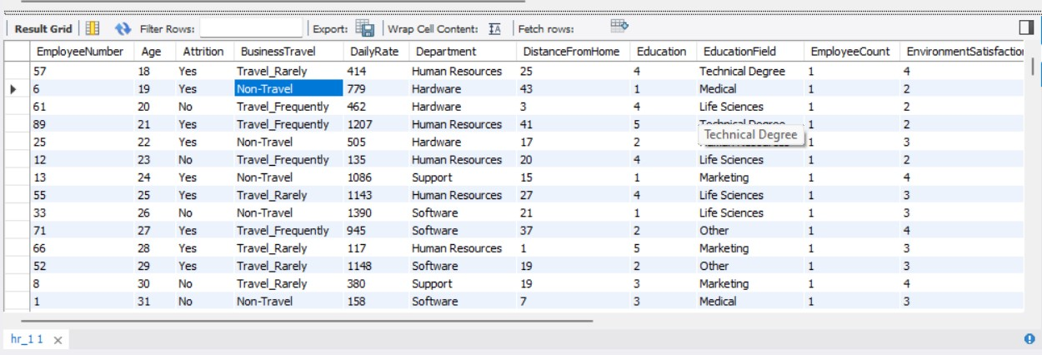

SELECT COUNT(*) FROM HR_1;

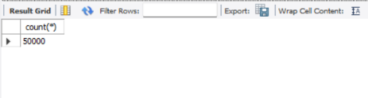

SELECT * FROM HR_2;

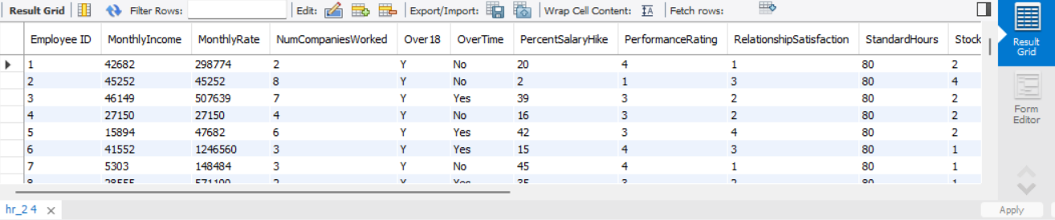

**-- JOINT 2 TABLES**

SELECT * FROM HR_1

JOIN HR_2 ON HR_1.EMPLOYEENUMBER = HR_2.`EMPLOYEE ID`;

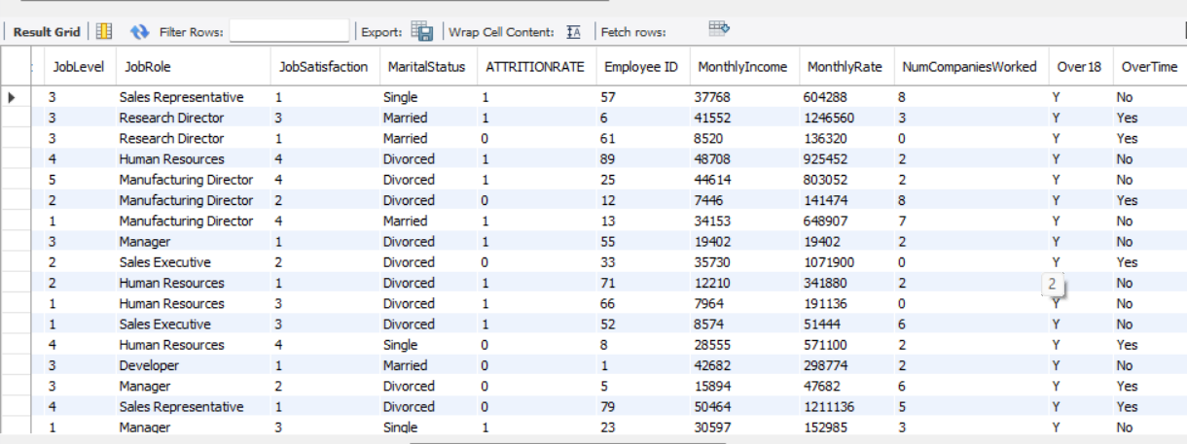

SELECT COUNT(*) FROM HR_2;

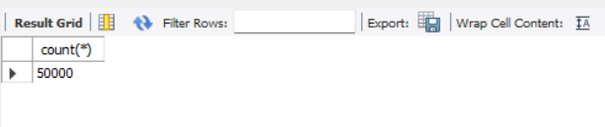

**-- TOTAL EMPCOUNT**

select count(EmployeeCount) from hr_1;

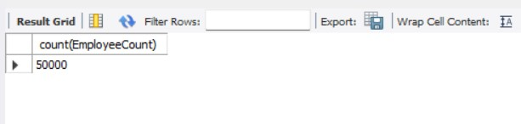

**-- TOTAL ATTRITION**

select count(*) as total_Attrition

from hr_1

where ATTRITIONRATE = "1";

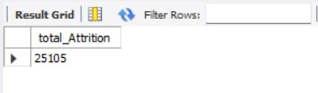

**-- AVERAGE AGE**

select round(avg(Age)) from hr_1;

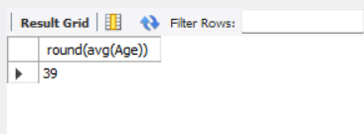

**-- TOTAL NO OF MALES**

select count(*) as total_males

from hr_1

where gender = "Male";

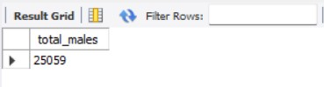

**-- TOTAL NO OF FEMALES**

select count(*) as total_females

from hr_1

where gender= "Female";

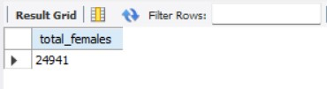

**-- ATTRITION RATE**

select

concat(round(sum(attritionrate) / sum(employeecount)* 100,2),'%') as Attrition_Rate

from hr_1;;

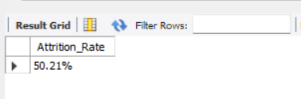

**-- ACTIVE EMPLOYEE**

select sum(employeecount) - sum(AttritionRate) as Active_Employee from hr_1;

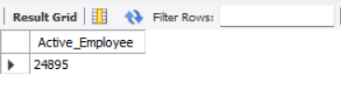

**-- JOB LEVEL STATUS**

select JobLevel, case

when joblevel = "1" then "Higher"

when joblevel = "2" then "High"

when joblevel = "3" then "Medium"

when joblevel = "4" then "low"

else "lowest" end as Job_Level_status from hr_1;

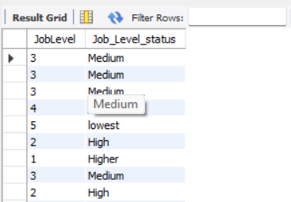

**-- JOB LEVEL STATUS COUNT**

SELECT

Job_Level_status, COUNT(*) AS LevelCount

FROM (SELECT JobLevel, **CASE**

WHEN JobLevel = '1' THEN 'Higher'

WHEN JobLevel = '2' THEN 'High'

WHEN JobLevel = '3' THEN 'Medium'

WHEN JobLevel = '4' THEN 'Low'

ELSE 'Lowest'

END AS Job_Level_status FROM hr_1 ) AS Subquery

GROUP BY Job_Level_status

order by Job_Level_status asc;

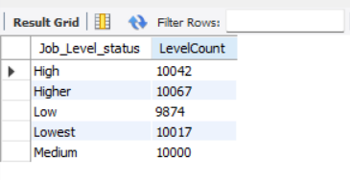

**-- ATTRITION COUNT BY JOBE ROLE**

select JobRole,

count(*) as Attrition_count

from hr_1

where ATTRITIONRATE ="1"

group by JobRole

order by Attrition_count asc;

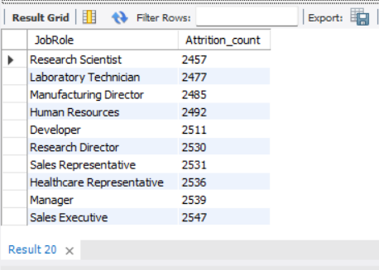

**-- BUSSINESS TRAVEL BY EMPLOYEE COUNT**

select BusinessTravel,

count(*) as Bussiness_Travel_Employee

from hr_1

where EmployeeCount=1

group by BusinessTravel

order by Bussiness_Travel_Employee asc;

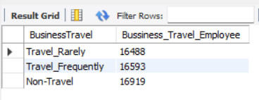

**-- ATTRITION BY GENDER**

select Gender,

count(*) as Gender_Attrition

from hr_1

where ATTRITIONRATE = "1"

group by Gender;

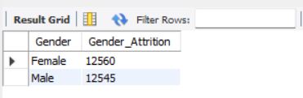

**-- EDUCATION FIELD WISE ATTRITION**

select EducationField,

count(*) as Education_Field_Attrition

from hr_1

where ATTRITIONRATE = "1"

group by EducationField

order by Education_Field_Attrition desc;

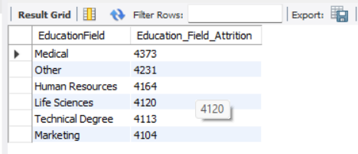

**-- EMP_ID WISE JOB SATICFACTION**

select h.`Employee ID`,

max(

case

when js.JobSatisfaction <=2 then "High"

when js.JobSatisfaction =3 then "Medium"

else "Low"

end) as Job_Saticfaction

from hr_1 as js

inner join hr_2 as h

on h.`Employee ID` = js.EmployeeNumber

group by h.`Employee ID`;

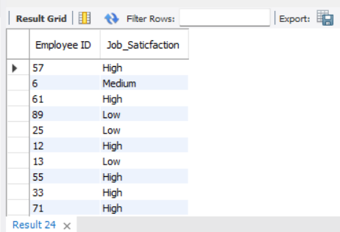

**-- ONDUTY VS DUETORETIERED**

select YearsAtCompany, case

when YearsAtCompany >= "22" then "Due_To_Retiered"

else "On_Duty"

end as Retirement from hr_2

group by YearsAtCompany

Order by Retirement;

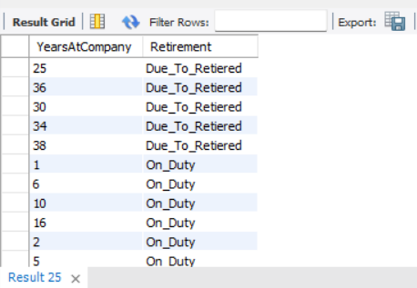

**-- EMPLOYEES WISE PERFORMANCE RATING**

select `Employee ID`, PerformanceRating, case

when PerformanceRating <= "3" then "HighRating"

else "low_Rating"

end As Performance_rating from hr_2

order by `Employee ID`;

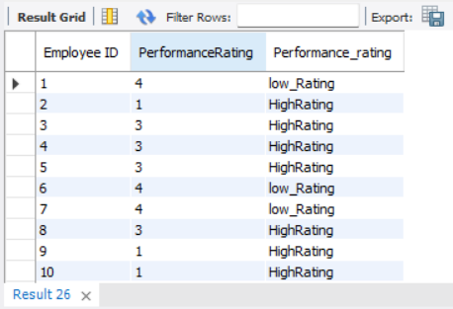

**-- UNIQUE DEPT WISE JOB ROLE**

select distinct(department), jobrole from hr_1

inner join hr_2 on hr_1.EmployeeNumber = hr_2.`Employee ID`;

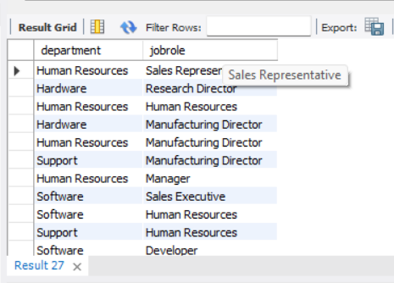

**-- DEPARTMENT WISE ATTIRITION**

SELECT

Department,

COUNT(*) AS total_employees,

SUM( ATTRITIONRATE = '1') AS total_attrition,

concat(ROUND(SUM(ATTRITIONRATE = '1') / COUNT(*) * 100.0 , 2),'%') AS attrition_percentage

FROM hr_1

GROUP BY Department

order by total_attrition asc; 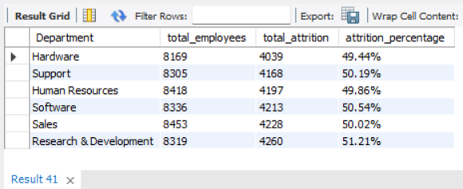

-- COUNT OF DEPARTMENT BY GENDER

select Department,Gender,

count(*) as count

from hr_1

group by Department,Gender

order by Department asc;

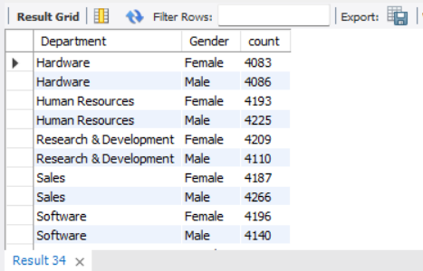

**-- JOB ROLE VS WORKLIFE BALANCE**

SELECT

hr_1.JobRole,

round(AVG(hr_2.WorkLifeBalance),2) AS AverageWorkLifeBalance

FROM

hr_1

JOIN

hr_2 ON hr_1.EmployeeNumber = hr_2.`Employee ID`

GROUP BY

hr_1.JobRole;

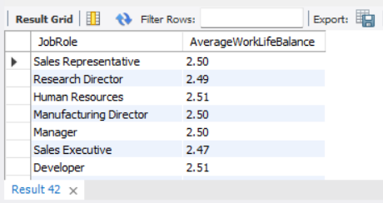

**-- COUNT OF DEPARTMENT BY GENDER**

select Department,Gender,

count(*) as count

from hr_1

group by Department,Gender

order by Department asc;

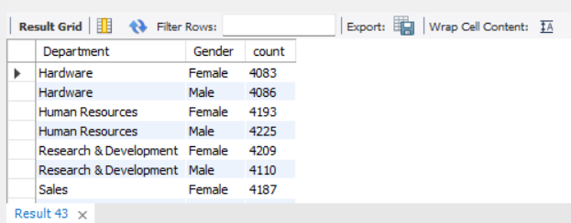

**-- AVERAGE WORKING YEARS FOR EACH DEPARTMENT**

select hr_1.Department,

round(avg(hr_2.Totalworkingyears),2) as AvgTotalWorkingYears

from hr_1

join

hr_2 on hr_1.EmployeeNumber = hr_2.`Employee ID`

group by Department;

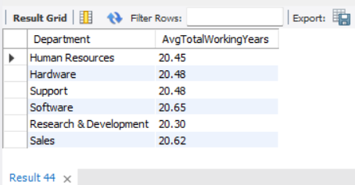

**-- ATTRITION RATE VS MONTHLY INCOME STATS**

select Department,

sum(hr_1.ATTRITIONRATE = '1') as AttritionRate,

concat(ROUND(SUM(ATTRITIONRATE = '1') / COUNT(*) * 100.0 , 2),'%') AS AvgAttrition,

round(avg(hr_2.MonthlyIncome),2) as AvgMonthlyIncome

from hr_1

join hr_2 on hr_1.EmployeeNumber = hr_2.`Employee ID`

group by Department;

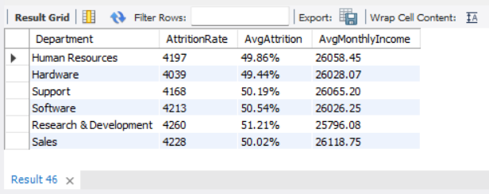

**-- AVERAGE MALE RESEARCH SCIENTIST**

select

round(avg(HourlyRate),2) as AvgHourlyRate_ResearchScientist

from hr_1

where JobRole = 'Research Scientist';

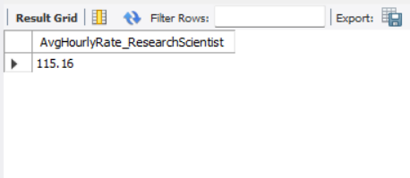

**-- Average Attrition rate for all Department**

select department,

concat(round(sum(attritionrate) / sum(employeecount)* 100,2),'%') as Attrition_Rate

from hr_1

group by Department;

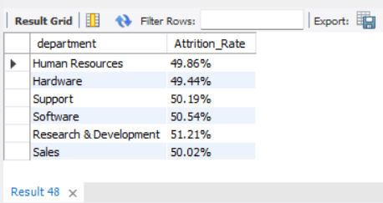

**-- ATTRITION RATE VS YEAR SINCE LAST PROMOTION RELATION**

select department,

round(avg(hr_2.YearsSinceLastPromotion),2) as YearsSinceLastPromotion,

concat(ROUND(SUM(ATTRITIONRATE = '1') / COUNT(*) * 100.0 , 2),'%') AS AvgAttrition

from hr_1

join hr_2 on hr_1.EmployeeNumber = hr_2.`Employee ID`

group by Department;

